Dolphin Water Tours Water Tour Reservation Form

Name: _______________________________ Age: _____ Today’s Date: ____/____/____

Selected Tour Time: ______ How Many Hours? ______ Requested Tour Date: ____/____/____

Half Day/4 Hours______ Full Day/6-8 Hours______ How Many in Your Party? 2 3 4 5 6

Is This for a Special Event? YES / NO If Yes, What? _______________________or Choose Below:
Birthday Anniversary Sunset Cruise Retirement New Job Graduation Bachelor / Bachelorette Party Single Again! Tanning Party Need Fresh Air Foliage Run

Destination Request: ____________________________________________________ or Choose Below:
Essex, CT - Old Saybrook, CT - Duck Island, Westbrook, CT - The Pavilion Old Lyme, CT Mystic, CT - Claudio’s / Greenport, Long Island, NY - Orient Point, Long Island, NY
Connecticut River North Destinations: Harbor Park, Middletown, CT - Hartford, CT

TOUR ORDERS: Cash/Check/Visa/Master CC# __________________________ Exp Date______

Tour Cost: ____#Hours ____Half Day $400.00 ____Full Day $650.00

Total Tour Cost: _________ Don’t forget a team shirt for a memory of your trip!
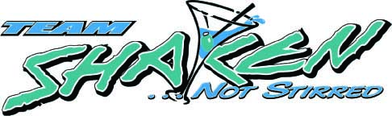 SHIRT ORDERS:
Size Availability Please Add 6% Sales Tax for Shirts

Unisex T-Shirts - $12.00 each L XL XXL Qty: ____ x $12 = Cost ______

Women’s Tank Tops - $12.00 S M Qty: ____ x $12 = Cost ______

Women’s Two Color T-Shirts - $14.00 S M Qty: ____ x $14 = Cost ______

Shirt Subtotal $________ 6% Ct Sales Tax ________
Total Shirt Cost: _________

For any Questions or Inquiries Please Contact us: jim@dolphin1.com

